**How this game works**

Thank you for your curiosity into how this game works!

The motivation behind creating this game was to introduce R in a fun way to those who are interested in coding or who may rely on R or statistical programming languages in the future. It is supposed to be easy to play for R beginners while also allowing players to go into the source code directly to see specifically how this program runs.

This document broadly outlines the structure of the R code and the logic R follows to play Tic-Tac-Toe. A detailed, step-by-step explanation requires reading the R source code (in the “code” folder) or contacting me (<https://github.com/Christopher-Blackford>)

**Visualizing Tic-Tac-Toe**

Plotting custom shapes in R can be tricky, so the visualization of the Tic-Tac-Toe board was done by using spatial data in R. This is why this game requires the *sp* and *rgeos* packages. The Xs, Os and game board are all stored as spatial line data. All possible X and O positions are generated at the beginning of the game, and a subset of those are displayed in the plot window, depending on the moves the player and computer make.

**How R/Computer understands player input**

The players input is stored in R in 2 ways. First, it is stored as a visualization on the game board, that can be seen in the plotting window. It is also stored, “behind the scenes” in a 3x3 matrix that mimics the game board.

At the beginning of the game, this 3x3 matrix is filled with zeros. Each time the player moves, it replaces one of these zeros with a 1. Each time the computer moves, it replaces one of these zeros with a 10. The replacement occurs in the same location on the game board as in the matrix:

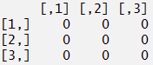 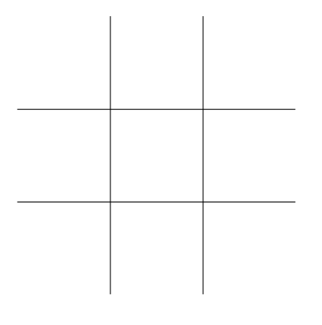

*At beginning of game, both board and matrix are empty*

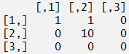 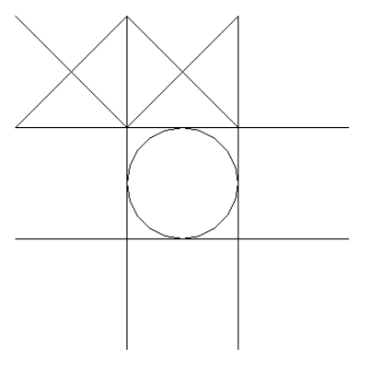

*Example of the game board and matrix after 3 turns*

By summing the rows, columns, and diagonals of the matrix, the computer can infer the positions of the Xs and Os across the board.

**How R/Computer plays against the player**

Tic-Tac-Toe is a simple enough game that, by following a few rules, the computer can ensure it will never lose a game.

The first computer move is coded different from the subsequent moves to respond optimally to the opening player move. If the player moves into any corner space, the computer moves into the centre. If the player moves into the centre, the computer moves into one of the four corners. If the player moves into any of the other spaces (position 2,4,6, or 8), the computer moves into one of the adjacent corners.